Day 1- Saturday
Depart USA
- departs JFK

Day 2 - Sunday
• Arrive in Israel at Ben Gurion Airport - Tel Aviv and board our tour bus. (IF flights are on time)
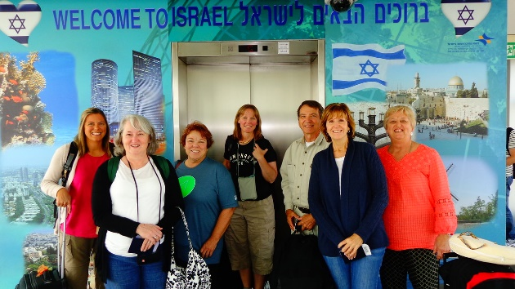
- Caesarea – site of one of Herod’s magnificent and opulent palaces, but most importantly, it is the Mediterranean port from which the Apostle Paul departed on his missionary journeys.
- ***** If arrive early enough to do – If not – Monday Morning
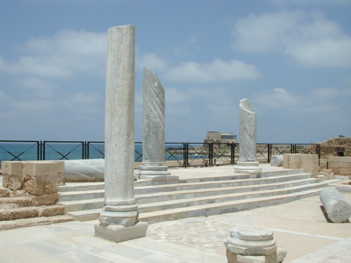
- Joppa – short walk through the streets of Old Joppa- Jonah fled the call of God from here. Peter saw the vision that led to his going to Caesarea to share the gospel with Cornelius.
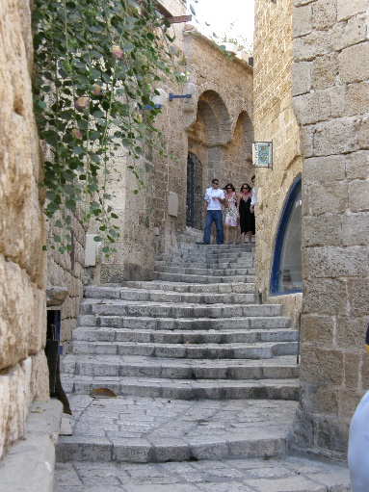

- Dinner
- Overnight: Haifa– Port city located at the base of Mt. Carmel.

Day 3 –Monday
• Breakfast at the hotel ~ Check-out and board bus

- Caesarea – site of one of Herod’s magnificent and opulent palaces, but most importantly, it is the Mediterranean port from which the Apostle Paul departed on his missionary journeys.

- Mt. Carmel - Best known for the contest between the Prophets of Baal and the Prophet Elijah in 1 Kings 18:19-20
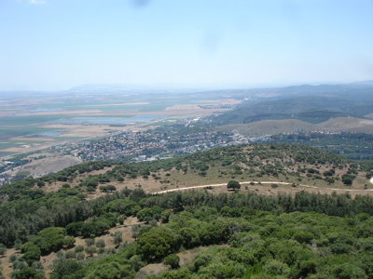

• Galilee
- Nazareth Village
- Mt. Precipice

- Dinner & Overnight: beside the Sea of Galilee

Day 4 – Tuesday

• Breakfast at the hotel
- Mt. of Beatitudes
• Sail across the beautiful Sea of Galilee
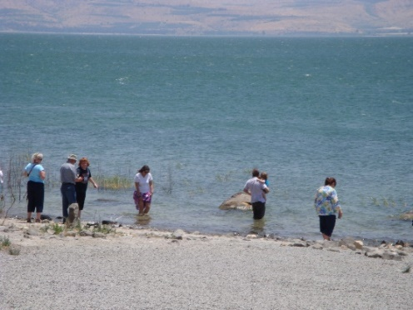
“Jesus Boat” Museum/ Yigal Alon Museum
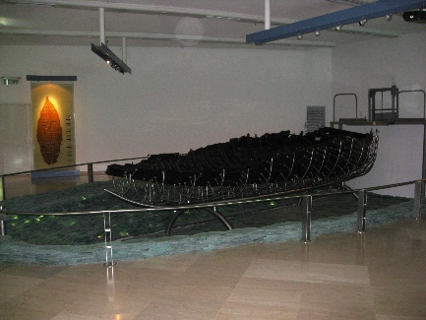

• Capernaum - The fishing village which served as home during Jesus' Galilee ministry
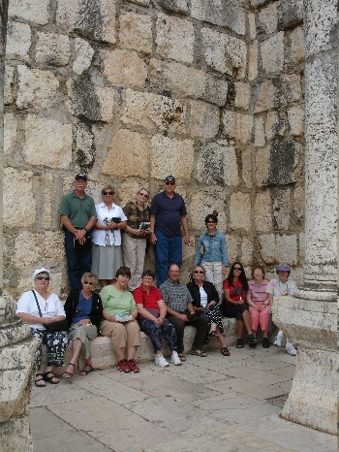

• Afternoon - Yardenit - Experience baptism at Yardenit, in the Jordan River, located at the southern tip of the Sea of Galilee (if you want to be baptized, you may rent a gown here/ with the rental comes a certificate).
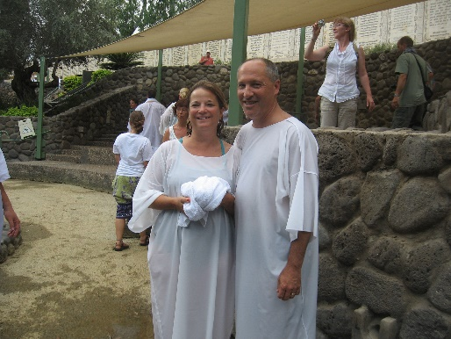

• Dinner & Overnight in Galilee

Day 5 – Wendsday

- Breakfast at the hotel
- Working Kibbutz
• Qumran - This area is the location of the caves where the Dead Sea Scrolls were found by a young shepherd boy. Legend has it John the Baptist once studied here with the Essences.
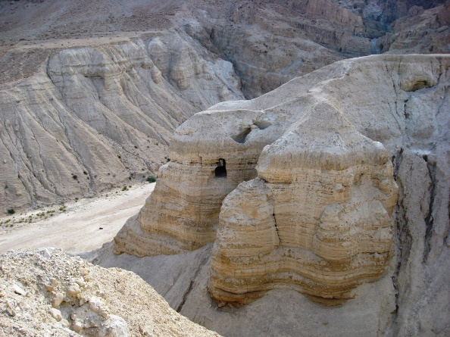

• En Gedi - was a source of renewal and strength for David and his men as they fled King Saul. David would replenish in the Living Waters of En Gedi as we replenish in the Living Waters of God's Word. As a deer panteth after the water brooks, so my soul panteth after thee, my God. (Psalms 42:2)
• Dead Sea - The warm waters of the Dead Sea with the salt content 28 - 30 times stronger than any ocean is said to offer many medicinal remedies. Jump in and see if you can sink.

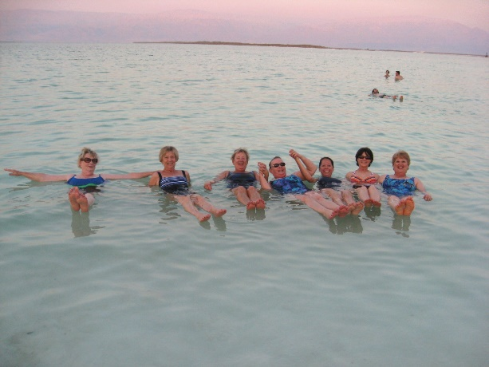

- Jerusalem overlook ~ a view of the old city of Jerusalem.

• Dinner

After Dinner:

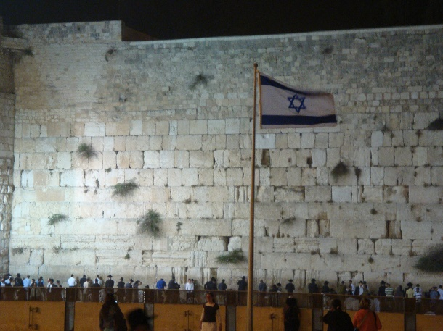
• Rabbi Tunnel - This tunnel runs underground along the base of the Temple Mount. We will have a wonderful tour and learn how the stone were crafted and moved into place to create the amazing foundation of Temple Mt.
- Western Wall at night
- Overnight: Jerusalem

Overnight: Jerusalem
1-866-599-6674 1-866-599-6674 1-866-599-6674
Day 6 – Thursday

• Breakfast at the hotel

- The Israeli Museum with the Jerusalem Miniature from the days of King Herod and The Shrine of Books (the Dead Sea Scrolls presentation).
• Yad Vashem – The home for the Holocaust Martyrs and Heroes. While heading to our next destination we will pass by the Government Center and the Knesset – Israel’s Parliament
- City of David - The story of the City of David began over 3,000 years ago, when King David left the city of Hebron for a small hilltop city known as Jerusalem, a tour through the City of David brings visitors face to face with the personalities and places of the Bible. This is the only place on earth where the only guidebook needed is the Bible itself.
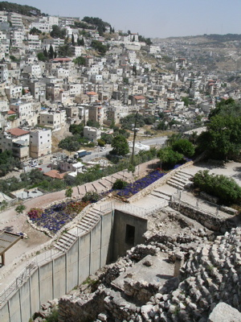
- Hezekiah’s Tunnel ~ Built during the time of King Hezekiah. Walk through, exiting at
- Pool of Siloam ~ Site of healing of blind man.
- 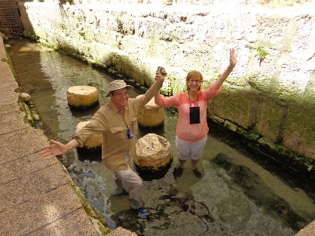
- Temple Mt.
- Davidson Archeological Park
- New City
- Dinner & Overnight: Jerusalem

Day 7 - Friday
• Breakfast at the hotel
- Mt. of Olives - The first stop will be the Mt. of Olives where Jesus ascended into heaven. Take a moment to reflect back to that day and time while your eyes gaze upon the panoramic view of the Holy City. The presence of God is all about, cast your eyes toward the Eastern Gate, and envision the triumphant return of our Lord in all His glory.
• Garden of Gethsemane - Pray among the olive trees as the Lord did nearly 2,000 years ago. What an impact this very night has had on the world when the Son of God submitted to the will of his Father.
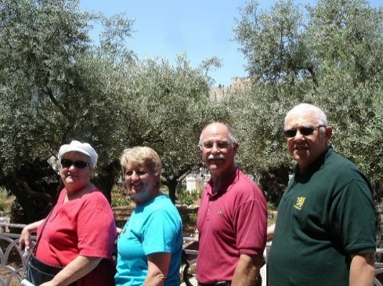
- Via Delarosa ~ the way of the cross.

- Garden Tomb - As Jesus was led through the Damascus Gate, he struggled toward Golgotha (Gordon's Calvary), where He was crucified for all sinners. He was buried in the Garden Tomb, from which he arose after the third day. Victory over hell, death and the grave is ours, because He has risen.
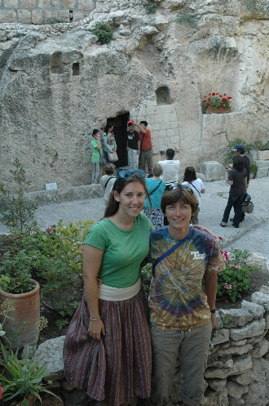

- Bethleham
- Depart for Ben Gurion Airport –late flight
- Dinner at Airport – on your own

Day 8-Saturday

- depart TLV
- Arrive in USA/JFK

