Going with Bless Israel Tours is like going with no other group!

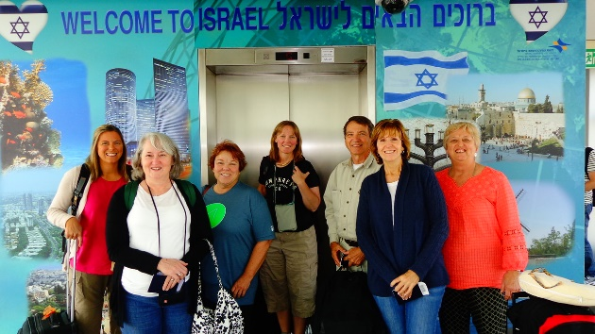
Picture yourself in the Holy Land

What will I see & experience?

The following is not an itinerary but the kinds of activities that have been part of other trips, many of which we will experience.

- Caesarea – site of one of Herod’s magnificent and opulent palaces, but most importantly, it is the Mediterranean port from which the Apostle Paul departed on his missionary journeys.
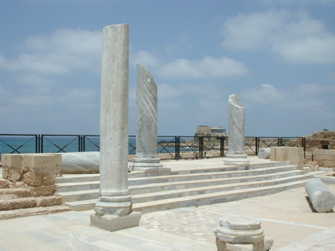

- Joppa – short walk through the streets of Old Joppa- Jonah fled the call of God from here. Peter saw the vision that led to his going to Caesarea to share the gospel with Cornelius.

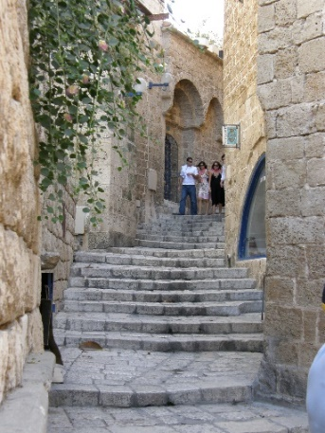

• Galilee
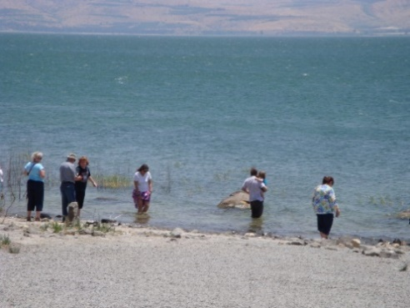

- Nazareth Village
- Mt. Precipice
- Mt. of Beatitudes
- Sail across the beautiful Sea of Galilee
• Capernaum - The fishing village which served as home during Jesus' Galilee ministry

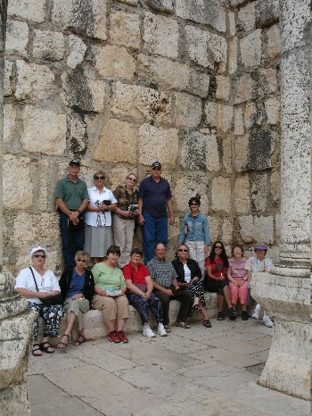

Yardenit - Experience baptism at Yardenit, in the Jordan River, located at the southern tip of the Sea of Galilee.

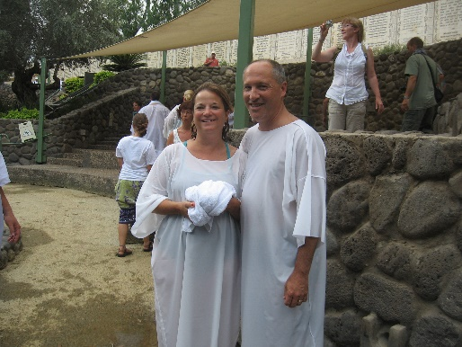

• Qumran - This area is the location of the caves where the Dead Sea Scrolls were found by a young shepherd boy.
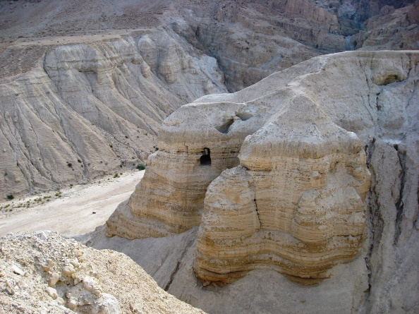

• En Gedi - was a source of renewal and strength for David and his men as they fled King Saul. David would replenish in the Living Waters of En Gedi as we replenish in the Living Waters of God's Word. As a deer panteth after the water brooks, so my soul panteth after thee, my God. (Psalms 42:2)

- Masada - Once the Palace of Herod, and then a refuge for zealots, it is considered by some the Gamla of the South. Eventually conquered by the Romans, Masada offers a magnificent view of the Dead Sea.

• Dead Sea - The warm waters of the Dead Sea with the salt content 28 - 30 times stronger than any ocean is said to offer many medicinal remedies. Jump in and see if you can sink.

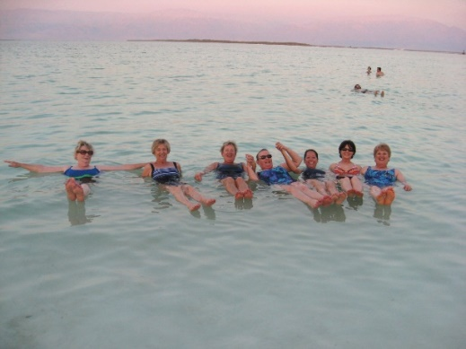

- Jerusalem overlook ~ a view of the old city of Jerusalem.
- Bethleham
- Western Wall

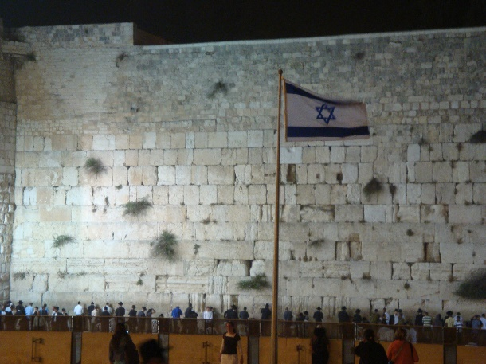
- Western Wall at night

- The Israeli Museum with the Jerusalem Miniature from the days of King Herod and The Shrine of Books (the Dead Sea Scrolls presentation).

• Yad Vashem – The home for the Holocaust Martyrs and Heroes. While heading to our next destination we will pass by the Government Center and the Knesset – Israel’s Parliament

- City of David - The story of the City of David began over 3,000 years ago, when King David left the city of Hebron for a small hilltop city known as Jerusalem, a tour through the City of David brings visitors face to face with the personalities and places of the Bible. 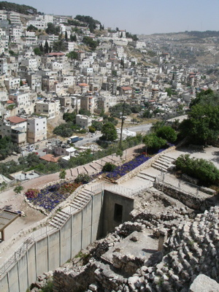

- Pool of Siloam ~ Site of healing of blind man.

- 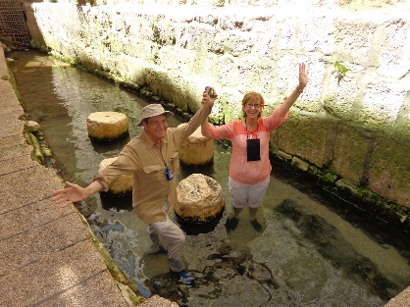

- Mt. of Olives - The first stop will be the Mt. of Olives where Jesus ascended into heaven. Take a moment to reflect back to that day and time while your eyes gaze upon the panoramic view of the Holy City. The presence of God is all about, cast your eyes toward the Eastern Gate, and envision the triumphant return of our Lord in all His glory.

- Garden of Gethsemane - Pray among the olive trees as the Lord did nearly 2,000 years ago. What an impact this very night has had on the world when the Son of God submitted to the will of his Father.

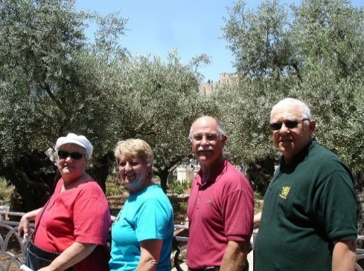
- Via Delarosa ~ the way of the cross.

- Church of the Holy Sepulchre

- Garden Tomb - As Jesus was led through the Damascus Gate, he struggled toward Golgotha (Gordon's Calvary), where He was crucified for all sinners. He was buried in the Garden Tomb, from which he arose after the third day. Victory over hell, death and the grave is ours, because He has risen.

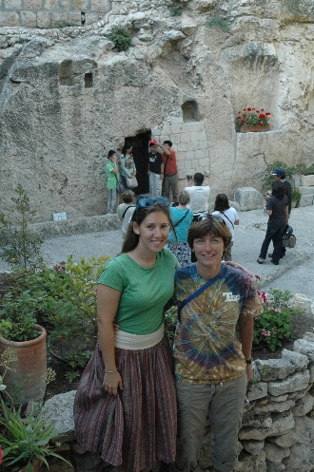

- Mt. Carmel - Best known for the contest between the Prophets of Baal and the Prophet Elijah in 1 Kings 18:19-20

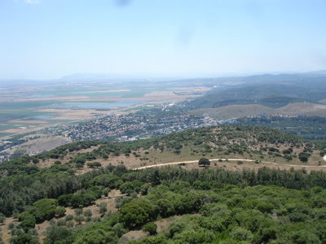

• Tel Dan - An ancient city and is the source of one of the largest branches of the Jordan River. In biblical times it marked Israel's northern border. It is now located in 100 acres of a glorious nature reserve. This is where the tribe of Dan located.

• Caesarea Philippi (Banyas) - "Who do you say that I am?" Jesus asked his disciples this question at this very spot. And Peter said, "Thou are the Christ, the Son of the Living God". And Jesus replied, "Upon this rock I shall build my church and the gates of hell will not prevail against it". (Matthew 16:16-18)
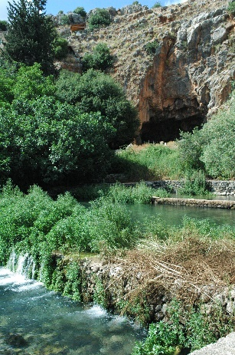
• Tel Bental - Stand atop a volcano that rises 3400 feet above sea level and see the plains of Syria where many modern and ancient battles have been fought.

JORDAN
- Petra - The city of Petra, capital of the Nabataean Arabs, is one of the most famous archaeological sites in the world. Petra is also known as the rose-red city, a name it gets from the wonderful color of the rock from which many of the city’s structures were carved.
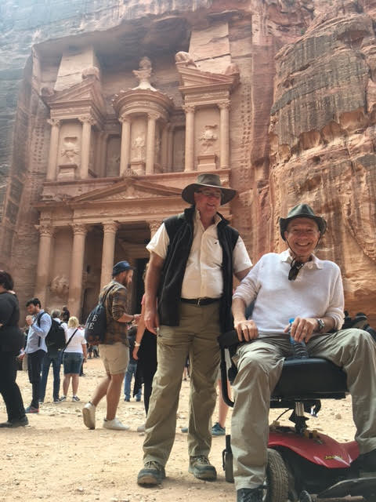

- Ride the camels with the Bedouins
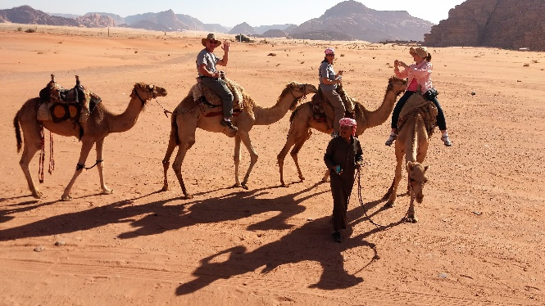
- 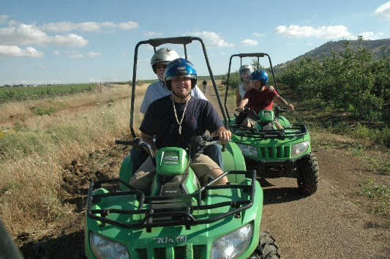
- We may even ride an ATV

- Red Sea for a day of snorkeling, swimming, and beach fun.
- 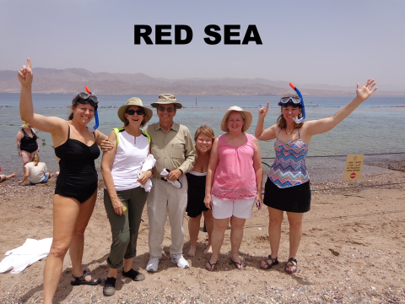
- Eilat’s location made it strategically significant during the many historical periods in which it served as a port – starting in the days of King Solomon (who built a large fleet of ships which he sent to Ophir), through the Nabataeans, the Romans, the Arabs, and the Crusaders, all of whom ruled the Land of Israel.
- Timna Valley Park~ The model of the Tabernacle in the wilderness A life-size replica of the biblical tabernacle, a tent that God is said to have instructed Moses to build in order to have a transportable sanctuary during the Exodus from Egypt to the Holy Land, was constructed in recent years in the park.
- 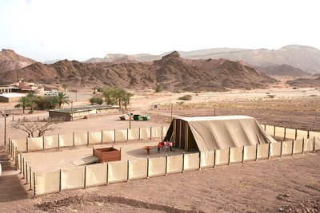
- Negev Desert ~ Israeli desert agricultural research has concentrated on developing new technologies that enable farmers to use brackish (salty) water for agricultural irrigation, something which had never been done before in any other place in the world. The Negev Desert has very little fresh water but an almost unlimited underground supply of brackish water, now used extensively for agriculture. Since brackish water is abundant in most desert areas of the world, the Israeli techniques have broad international applications.
• Archeological Dig at Bet-Govin National ~ The people who lived at Beit Govrin thousands of years ago left behind plentiful testimony to their existence both above and below ground. Among the sites are a Roman amphitheater and Beit Govrin National Park ,Tel Mareshah, which was fortified by Solomon’s son Rehoboam (2 Chron. 11:8).
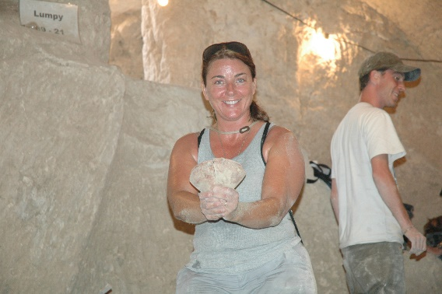

Making new friends is an added bonus

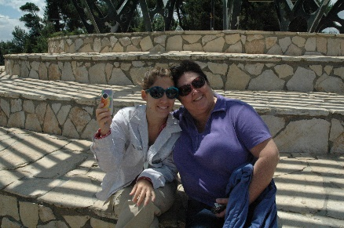

Why go to Israel with BLESS ISRAEL TOURS?
- We only take small groups so that every person can experience the absolute most possible and not waste time waiting on the herd.
- We arrange for each person to meet and interact with “living stones” (people that God is using to redeem His land). 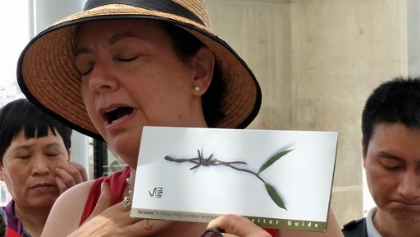
- Before we go we do an extensive Bible study of the places we will visit.
- We are guided by a Messianic Jew who both has an incredible knowledge of the land and its history and a deep love for the Messiah, Jesus Christ. 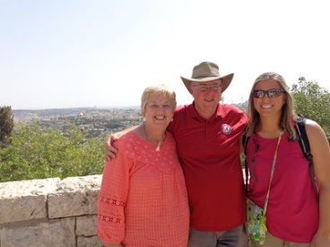
- We have an amazing bus driver who knows this marvelous land like few others
- We go places and seize opportunities that typical tour groups would never do. Who do you know who have actually been digging at a real archeological site; snorkeled in the Red Sea; celebrated in the streets with Israelis at the beginning of the year of Jubilee; worshiped with local believers on Mt. Carmel; ridden jeeps through the desert; helped local Bedouins prepare lunch under an acacia tree; or went four-wheeling on the Golan Heights? 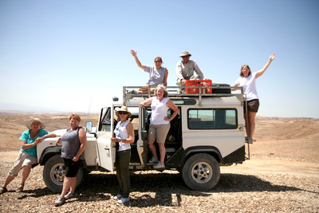
- Our flights are at night to reduce jet-lag.
- Our flight schedule allows us to get some experiences in on that very first day we land (you get extra touring time).
- Our last day in the country is a full (extended) day of touring before we head to the airport (You basically get an extra day).
- You never have to worry about who or how much to tip. We take care of all of that.
- You will get more for your money than any other tour company! $$

Going with Bless Israel Tours is like going with no other group!

